

**كلية تكنولوجيا المعلومات**

Faculty of IT

Veterinary Clinic System

*Students:*

|  |  |
| --- | --- |
| Yasmin Fadi Hababa | 202110369 |

*Supervisor:*

Dr. ALAA

*Amman - Jordan*

*2024/2025*

**Table of Contents**

1.1 Problem Statement and project Scope page 1

1.2 Project Plan and Schedule

2. System Analysis page 2

2.1 Functional Requirements

2.2 Use Case Diagram

3. System Design page 3

3.1 ER-Diagram (if a database will be used)

3.2 User Interface

* 1. Problem Statement and project Scope

The system has been facing problems due to its paper-based appointment

system. With the increase in the number of patients visiting, it has

become diﬃcult to manage the appointment system manually. Recording

of appointments and creating registers by pen and paper has become a

Veterinary clinics often rely on paper forms to record and manage pet and pet owner information. This manual process is inefficient, prone to errors, and challenging to maintain over time. Retrieving or updating information from paper records can be time-consuming, which impacts clinic productivity and service quality. The proposed website will address these challenges by providing veterinarians with an efficient platform to enter, extract, and modify information with ease.

The project aims to develop a website that streamlines the management of pet and owner information through the following objectives: providing veterinarians with an intuitive platform to quickly and accurately enter pet and owner details, enabling easy retrieval, modification, and extraction of records as needed, and eliminating the need for paper-based forms, improving clinic efficiency and reducing errors.

Additionally, the website will contribute to Good Health and Well-being (SDG 3) by supporting veterinary clinics in maintaining the health and well-being of animals, which directly impacts public health. This can be achieved by controlling zoonotic diseases (diseases that spread from animals to humans, such as rabies and avian flu) and promoting responsible pet ownership while reducing overpopulation through spaying/neutering.

* 1. Project Plan and Schedule

**The Figure 1 shows a Gantt chart and task management table for a project timeline, with the following details:**

1. Planning Phase: 5 days (28-Oct-24 to 01-Nov-24), 30% complete, priority 1000, assigned to the Project Manager.
2. Requirement Gathering: 7 days (25-Nov-24 to 03-Dec-24), 0% complete, priority 1000, assigned to the Team Lead.
3. Database ER-Diagram: 2 days (27-Nov-24 to 28-Nov-24), 0% complete, priority 500, assigned to the Developer.
4. Design UI/UX: 4 days (27-Nov-24 to 02-Dec-24), 0% complete, priority 700, assigned to the UI/UX Designer.

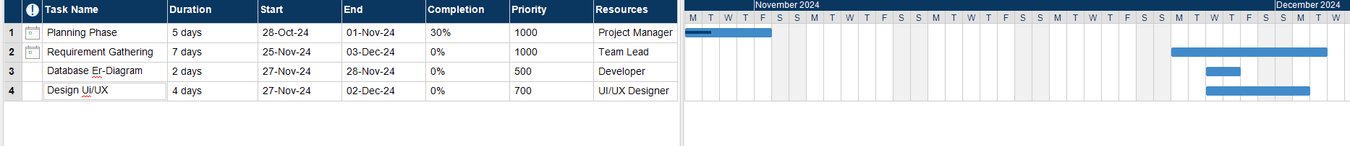

Figure 1: Gantt Chart of project

* 1. 2. System Analysis

2.1 Functional Requirements

1. User Management  
1.1. The system must provide a secure login mechanism for veterinarians.  
1.2. The system must provide a secure login interface requiring a username and password.  
1.3. Passwords must be stored securely using encryption.

2. Information Management  
2.1. Veterinarians must be able to add pet owner information (name, contact details, address).  
2.2. Veterinarians must be able to add pet information (name, species, and breed).  
2.3. The system must allow searching and filtering of pet or owner records.

3. Data Operations  
3.1. Veterinarians must be able to update existing pet or owner information.

2.2 Use Case Diagram

The Figure 2 Represents a Use Case Diagram for a veterinary system it illustrates the interaction between the Vet (Actor) and the system's functionalities.

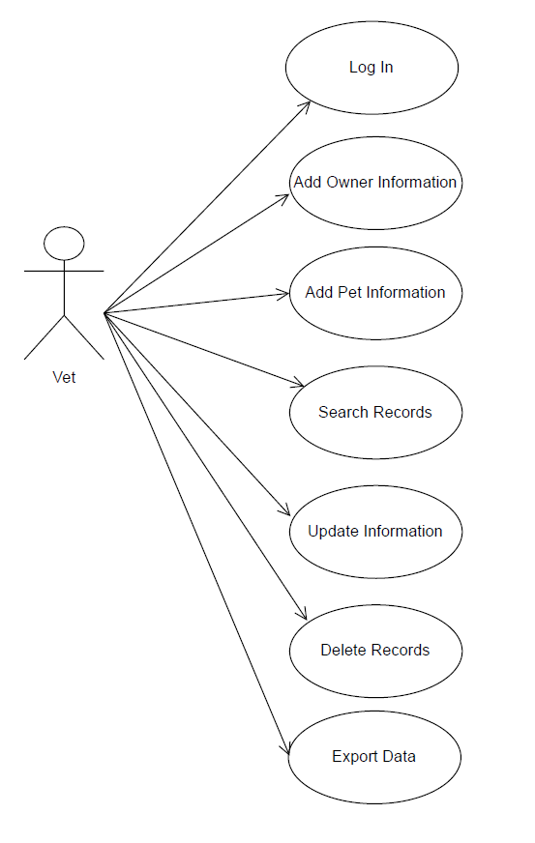

Figure 2: Use Case diagram of system

3.1 ER-Diagram

The Figure 3 Represents a diagram that shows the structure of the system, showing how pet information, owner details, and doctor records are interconnected.

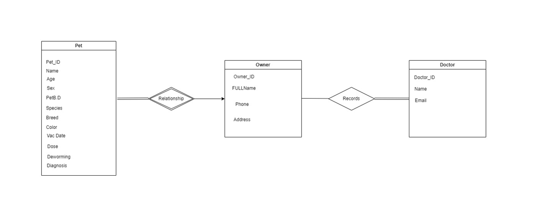

Figure 3: ER diagram of Appointment system

3.2 User Interface

The Figure 4 The registration page that allows the clinic administrator to register an account in his name

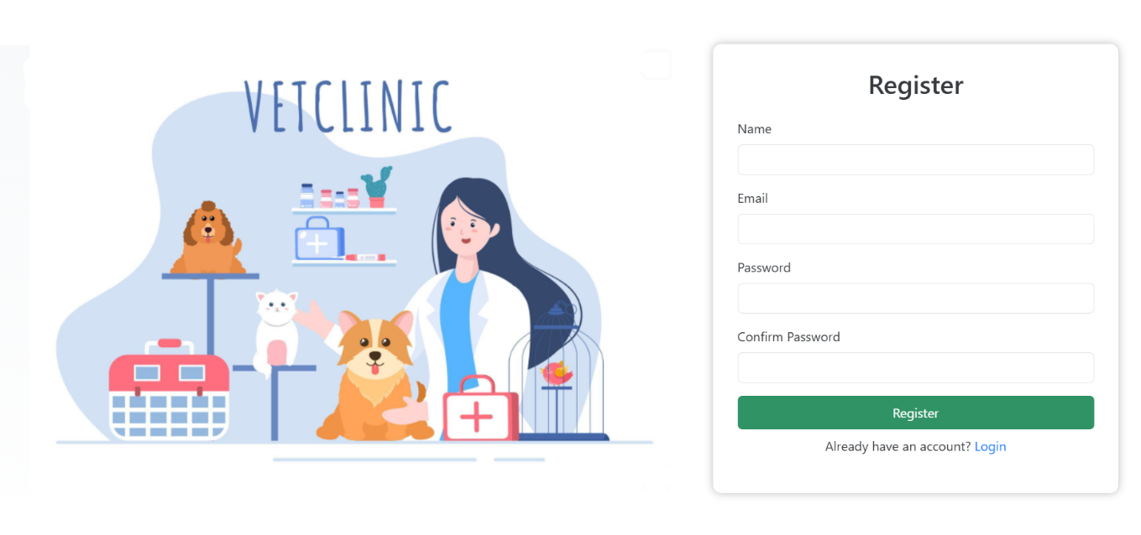

Figure 4: Main UI of Appointment system

The Figure 5 The login page where the user can log in with his registered account to the system

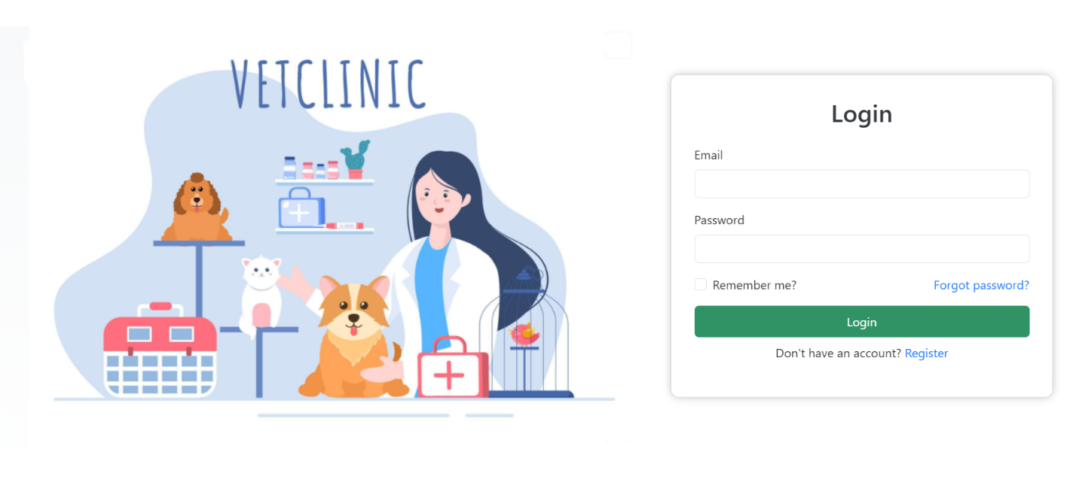

Figure 5: Main UI of Appointment system

The Figure 6 The home page where you can read the number of owners and pets and the number of upcoming appointments

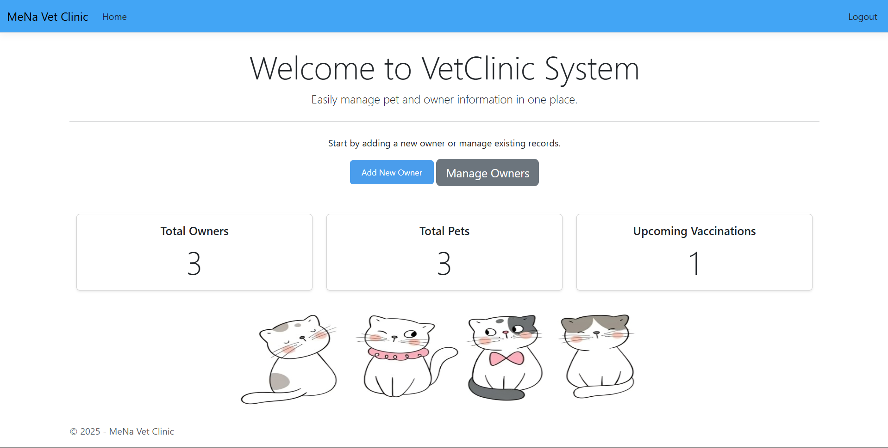

Figure 6: Show All UI of system

The Figure 7 Page to enter owner and pet information

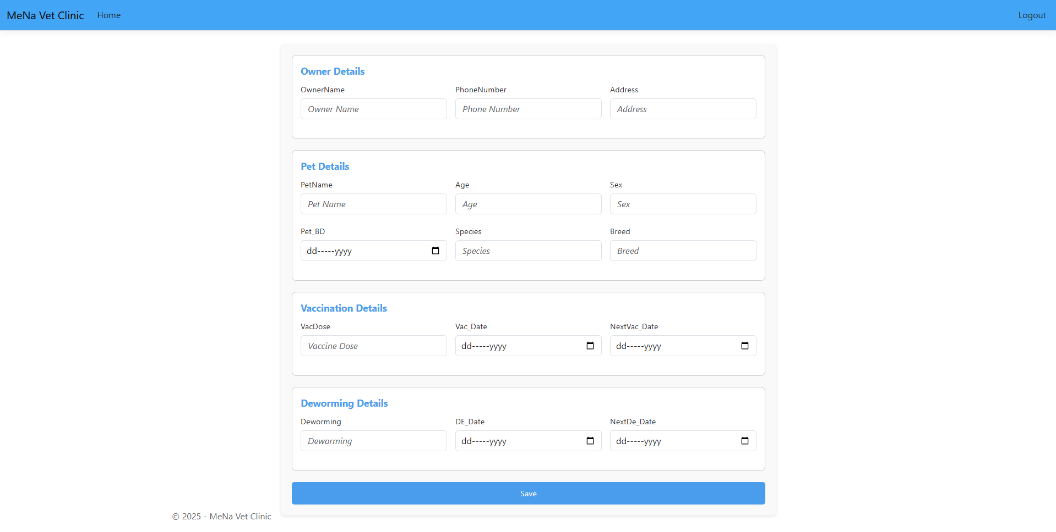

Figure 7: Show All UI of system

The Figure 8 This is the page through which all information can be displayed, searched within, modified or deleted.

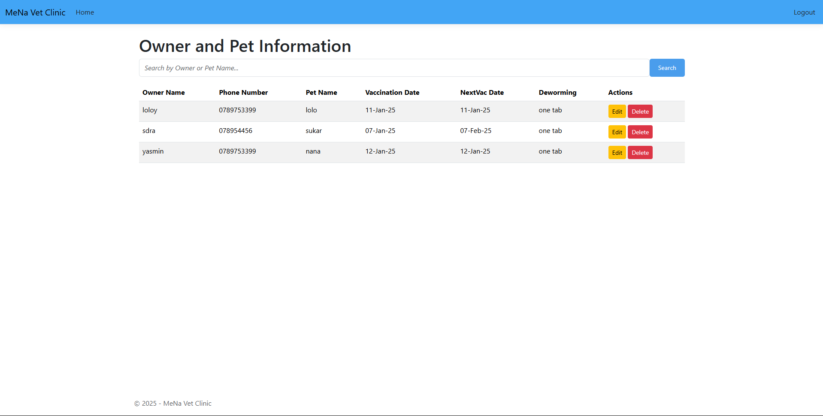

Figure 8: Show All UI of system